CUB SCOUT 1 (holds plane):
Every day, thousands of planes Take Flight to deliver people and things all over the world.

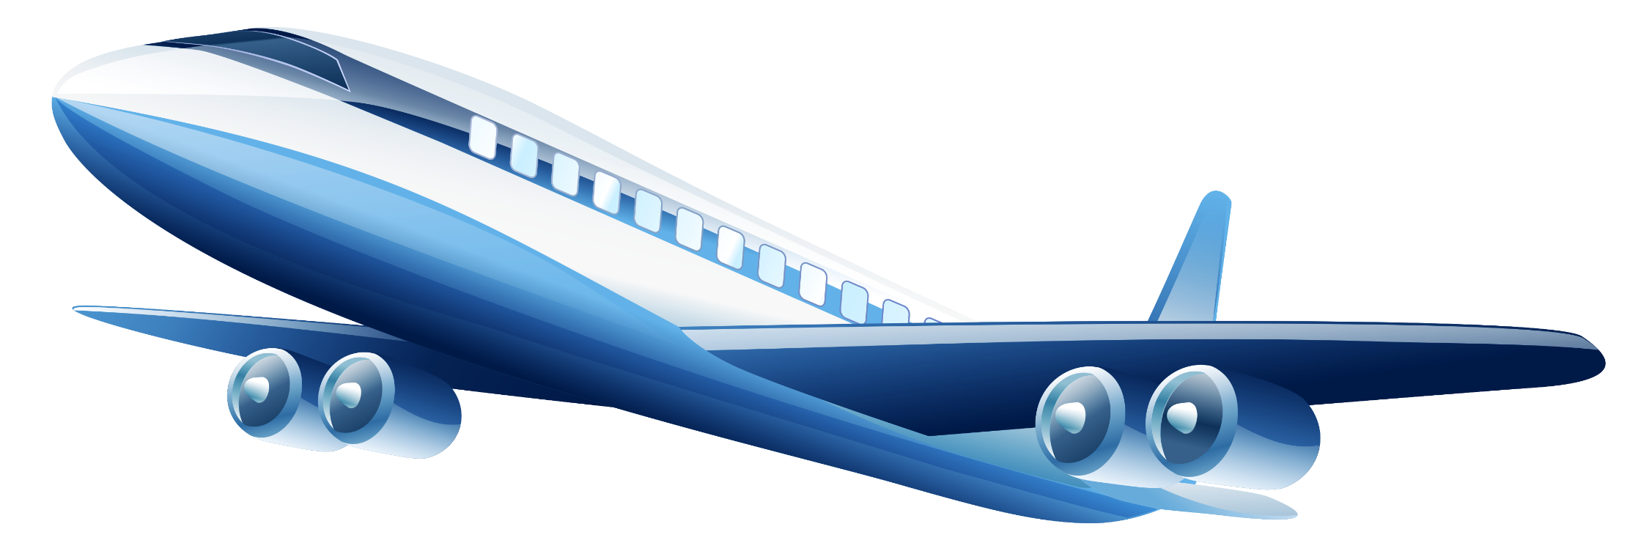
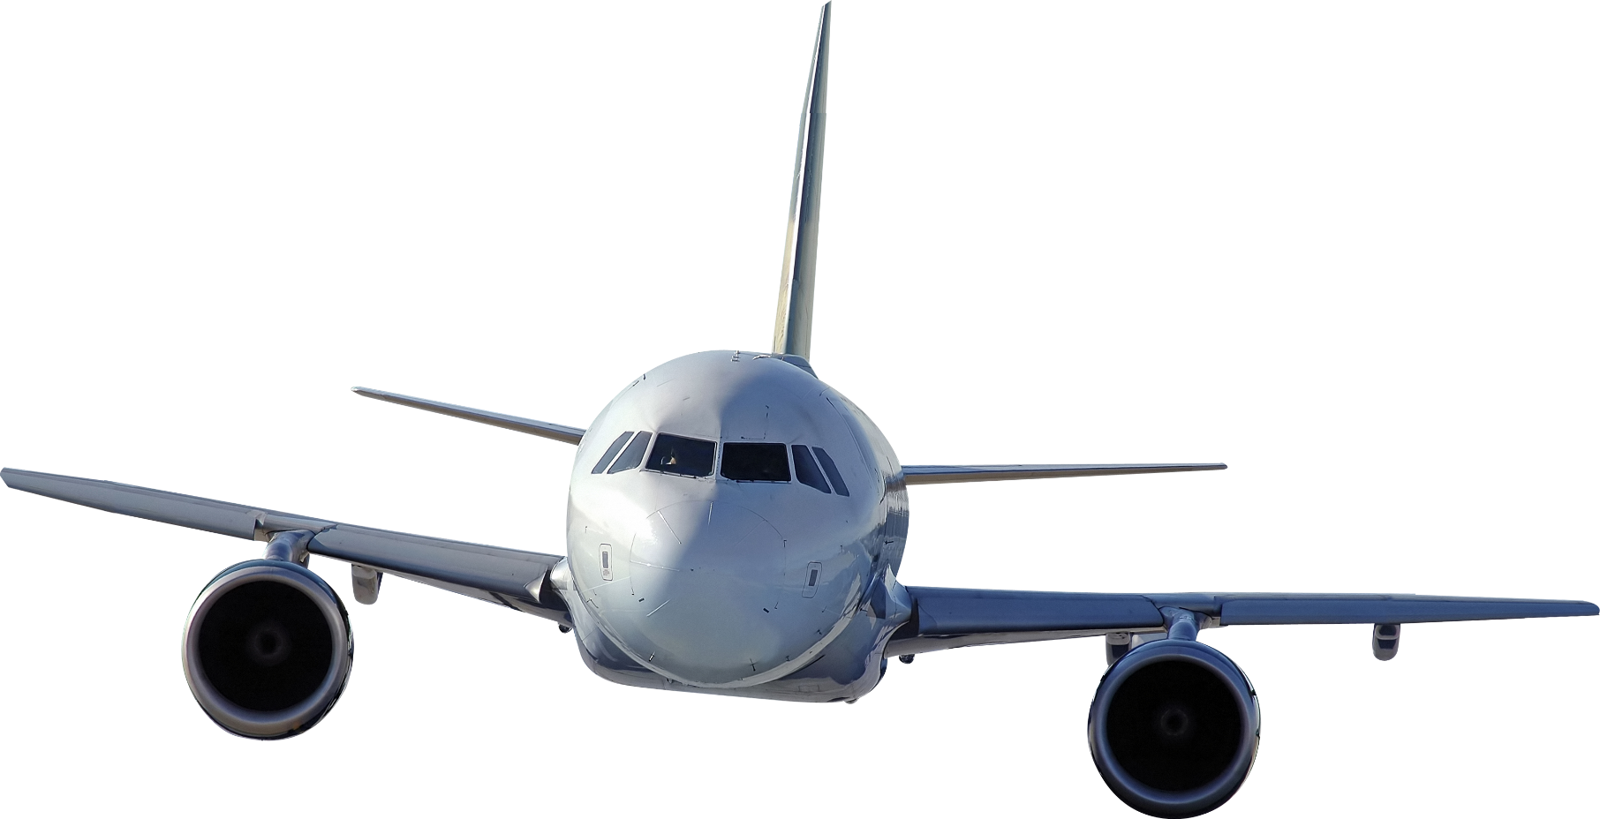

CUB SCOUT 2 (holds bird):
You can see many different birds Take Flight, making the world a more beautiful place.

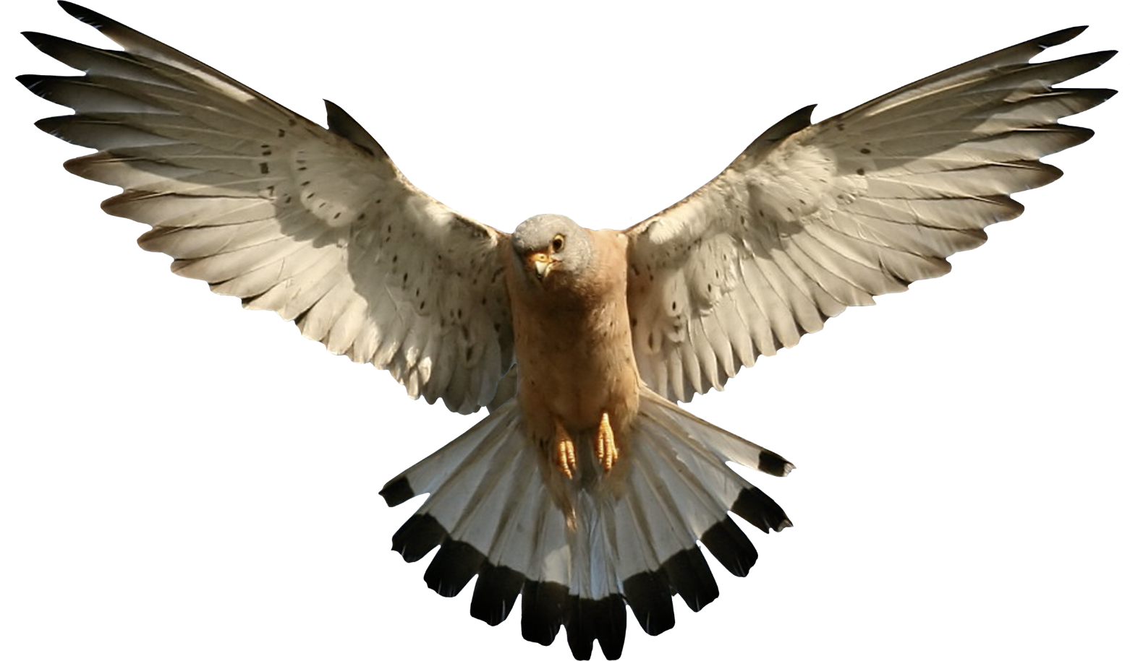
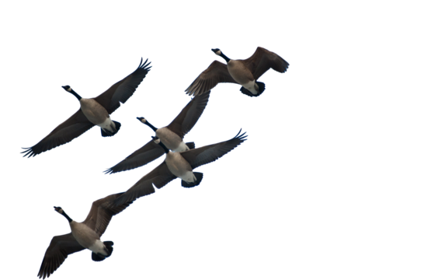
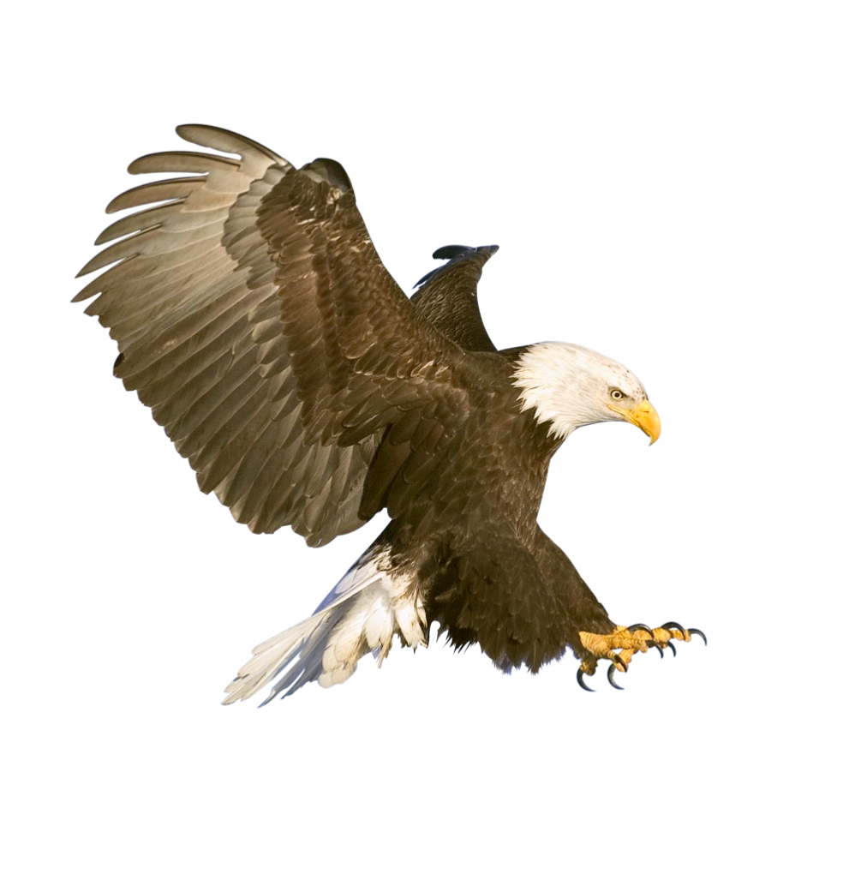

CUB SCOUT 3 (holds kite):
In the windy skies above, you could watch your own kite Take Flight. It's a good way to relax and enjoy a wonderful part of nature.

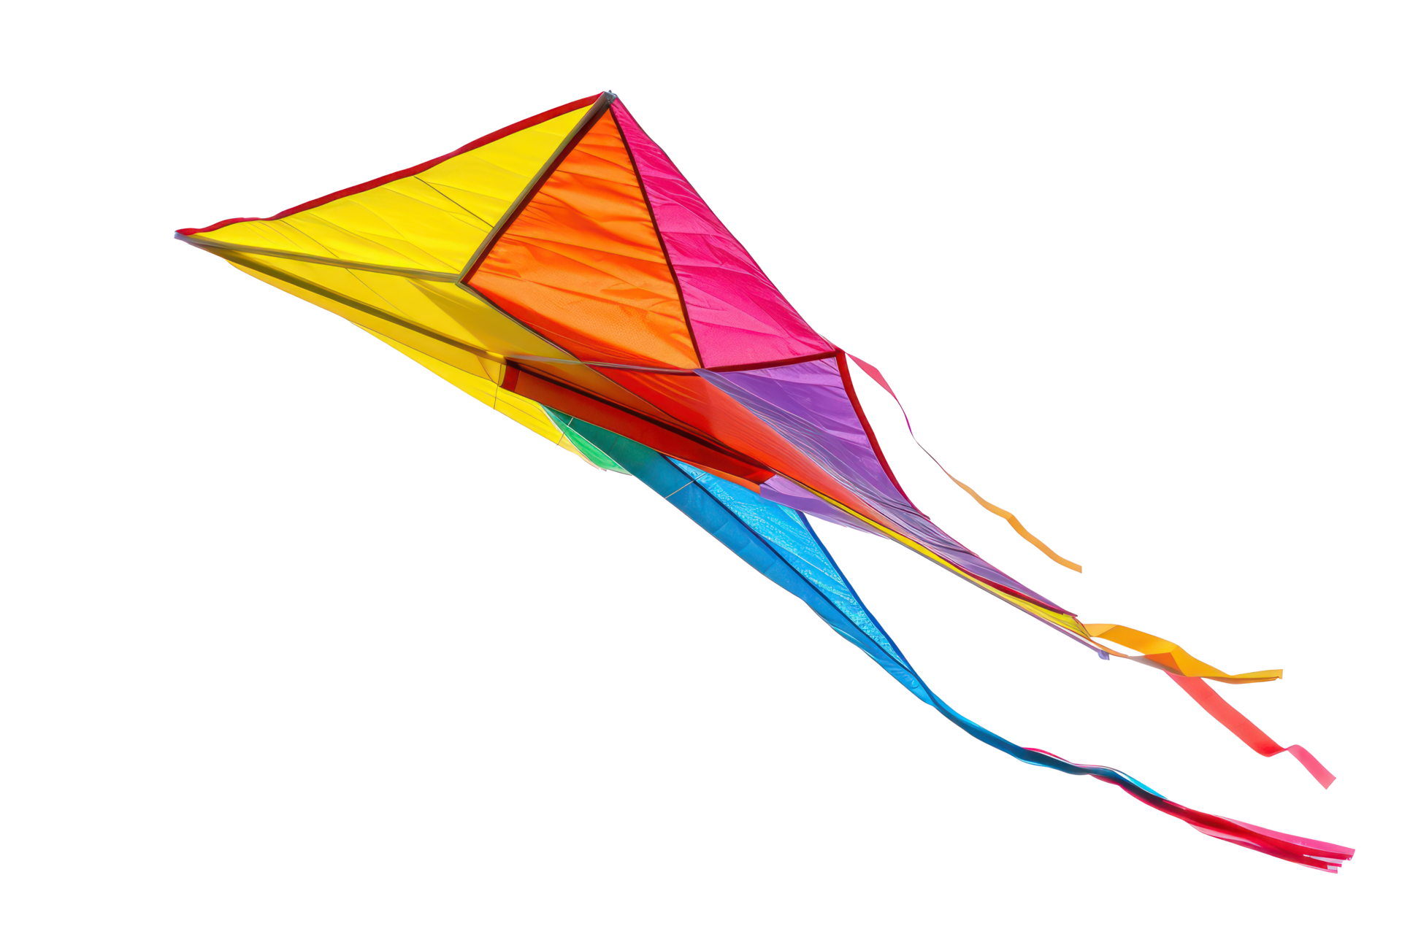
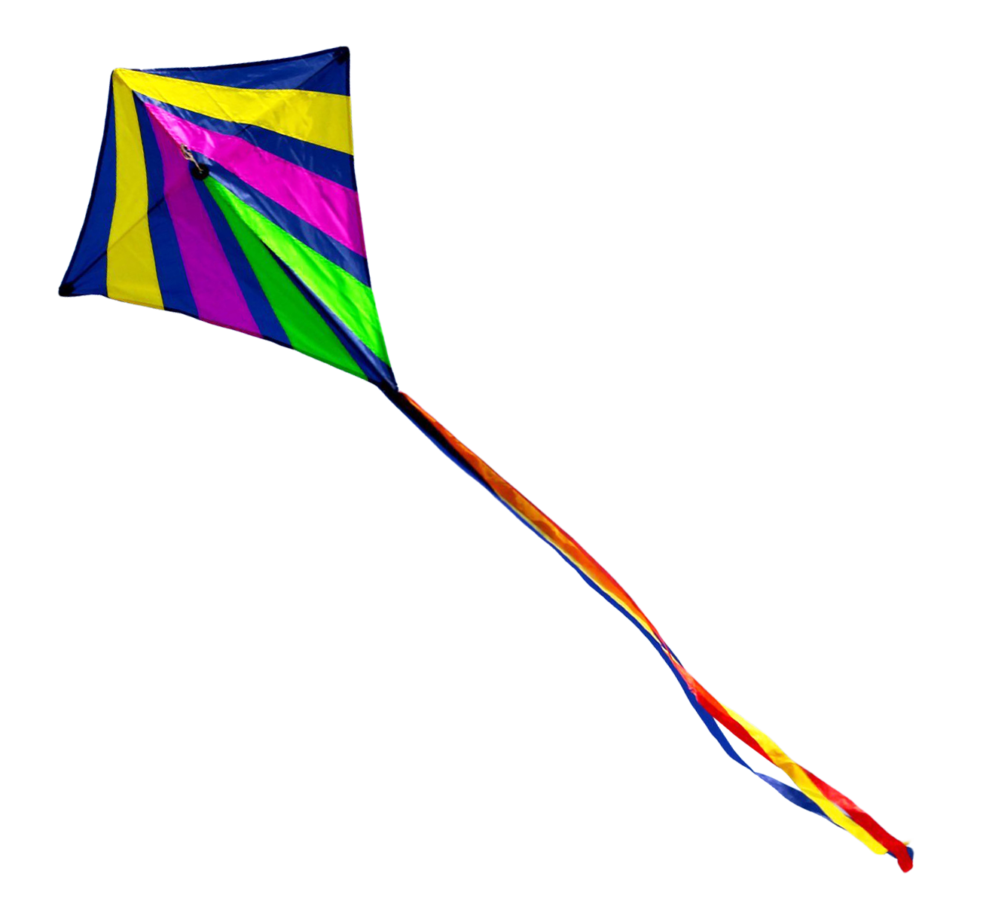
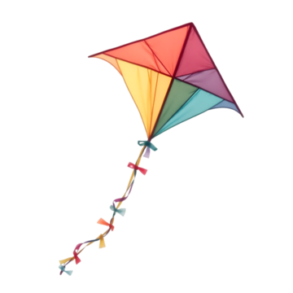

CUB SCOUT 4 (holds rocket ship):
It's so exciting to see rocket ships Take Flight and think about exploring the universe.




CUB SCOUT 5: Script
Does your heart stir as you see our national flag Take Flight? Please stand and join me in saluting this great flag while repeating the Pledge of Allegiance. (This Cub Scout can be the Flag Ceremony caller.)

